Chapter 4 Exam
ACCT2060
Out of Canvas potion Name Cassi Stephenson

1. |  | 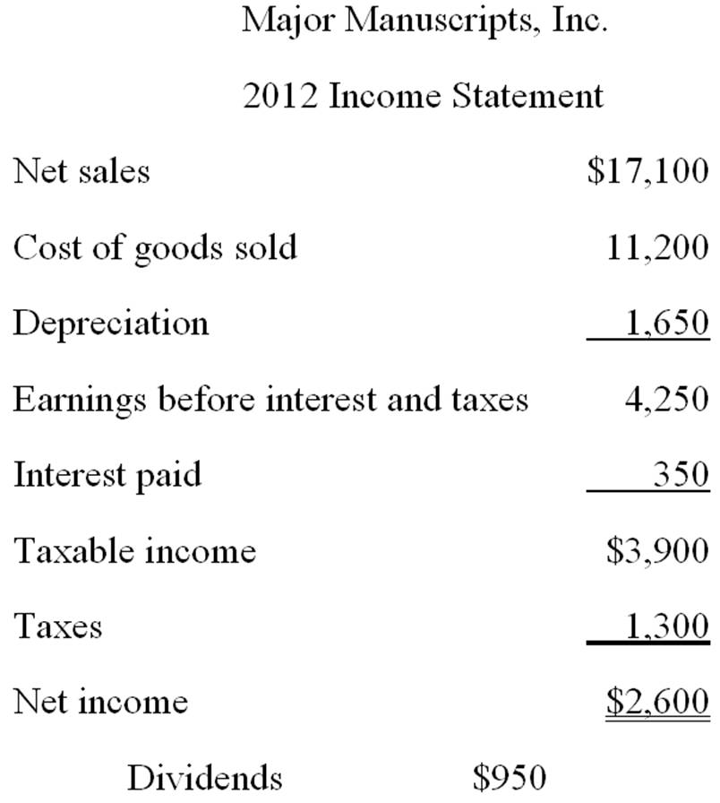  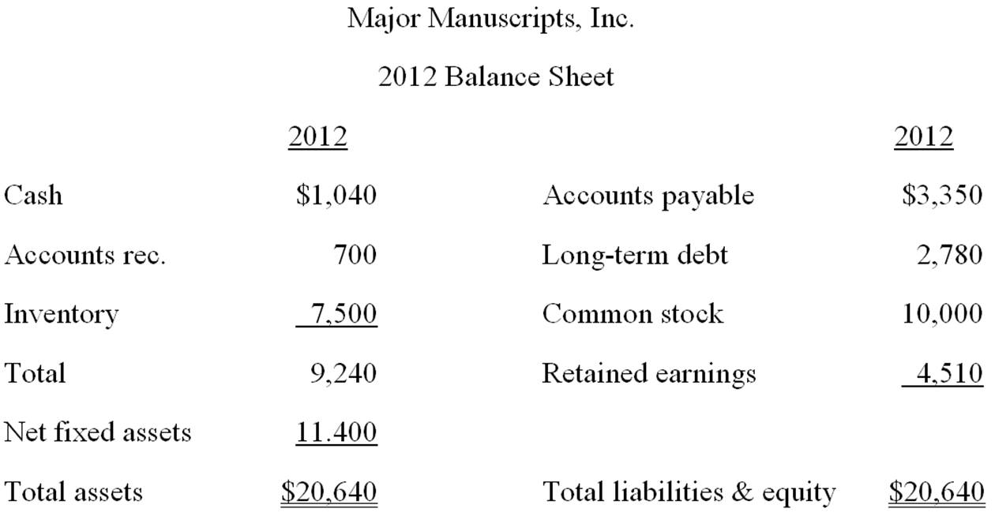  Major Manuscripts, Inc. is currently operating at maximum capacity. Cost of goods sold, depreciation, interest, all assets, and current liabilities vary directly with sales. The tax rate and the dividend payout ratio will remain constant. How much additional debt is required if no new equity is raised and sales are projected to increase by 6 percent?  Projected Total assets=20,640*1.06 = 21,878.40  Projected accounts payable=3,350*1.06 = 3,551  Current long term debt=2,780*1.06 = 2,946.80  Current common stock=10,000*1.06 = 10,600  Projected retained earnings= 4,510+[(2,600-950)*1.06] = 6,259  Additional debt required= 21,878.40-3,551-2,946.80-10,600-6259  Answer= -1,478.40
2. | Assume the profit margin, tax rate, and the payout ratios of Major Manuscripts, Inc. are constant. Also assume the cost of goods sold, depreciation, interest, all assets and current liabilities vary with sales. If sales increase by 9 percent, what is the pro forma retained earnings?
3. | 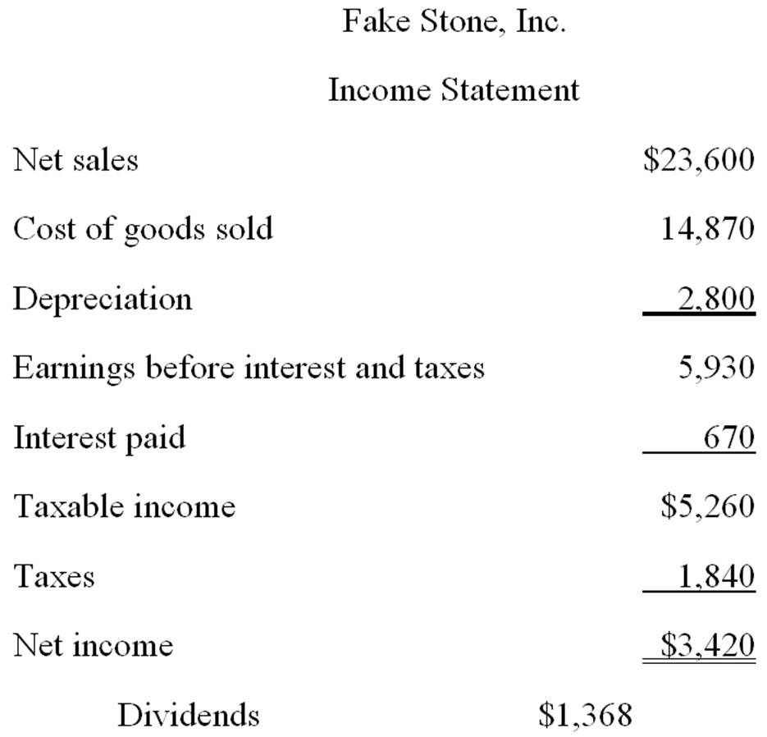  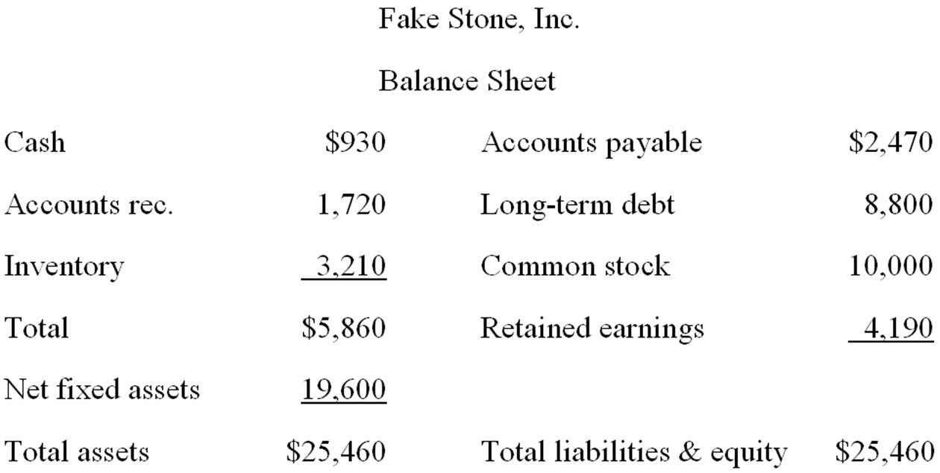  Assume that Fake Stone, Inc. is operating at full capacity. Also assume that all assets, cost of goods sold, depreciation, interest, and current liabilities vary directly with sales. The dividend payout ratio and tax rate are constant. What is the external financing need if sales increase by 12 percent?

